NAME: Debatwik Santra Roll No: CSE /23/110 Exam Roll No: 11600223047
Assignment No- 5 : Create a private bucket in AWS. Upload a file and check by predesigned URL whether you can access the file or not.
Solution:
Step 1: Login to AWS Console
- Open the AWS console login page.
- Login using Root User Credentials.
- Open AWS Management Console.
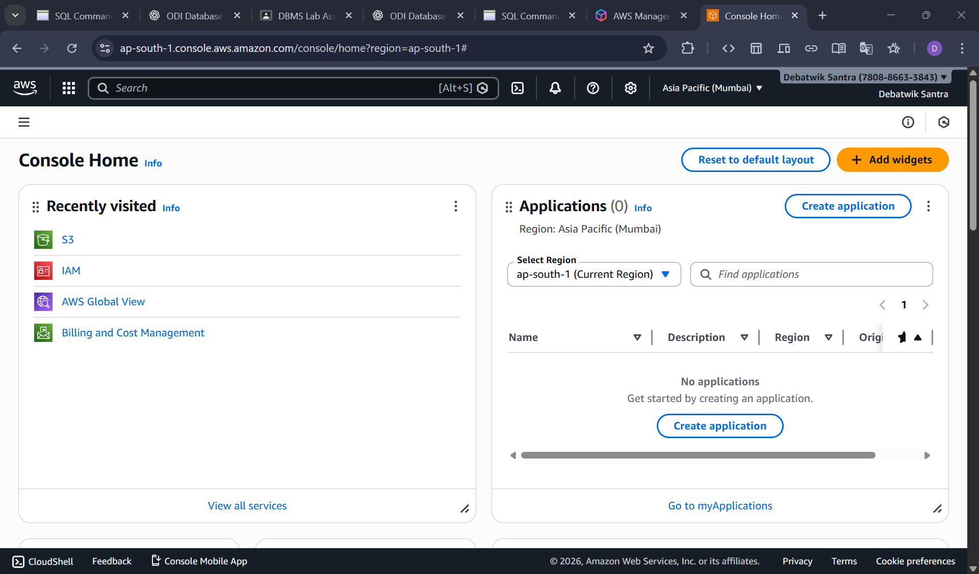
Step 2: Open Amazon S3
- In AWS Console, search S3 in the top search bar then Click Amazon S3
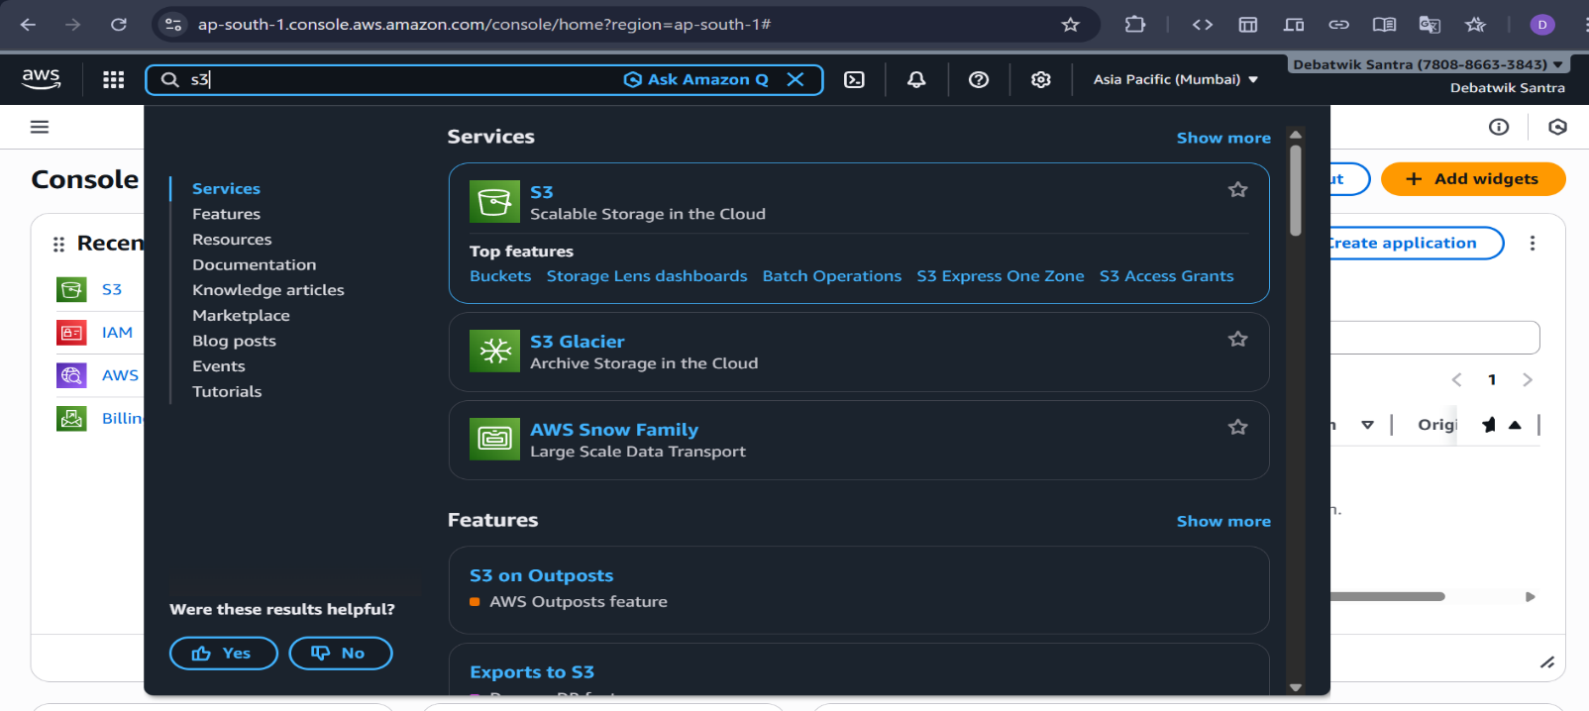
Step 3: Create a Private S3 Bucket
- Click Create bucket.
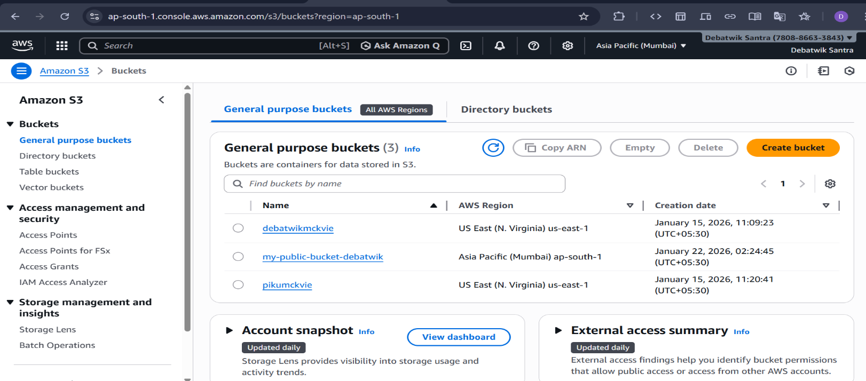
- Bucket name → must be unique
Example: my-private-bucket-piku
- AWS Region → select any (e.g., Asia Pacific – Mumbai )
- Under Object Ownership:
- Select ACLs enabled.
- Choose Buckets owner preferred
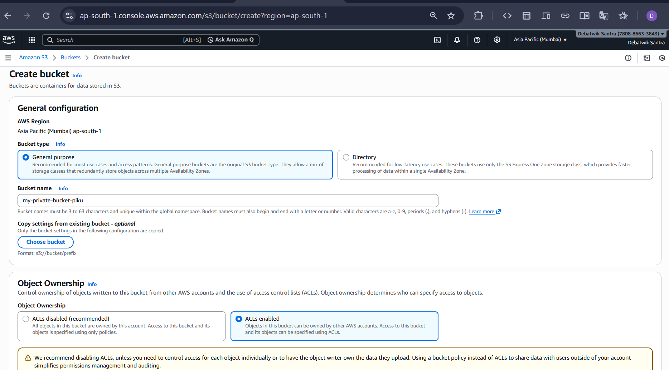

- Under Block Public Access
- Keep “Block all public access” ENABLED
- Acknowledge the warning
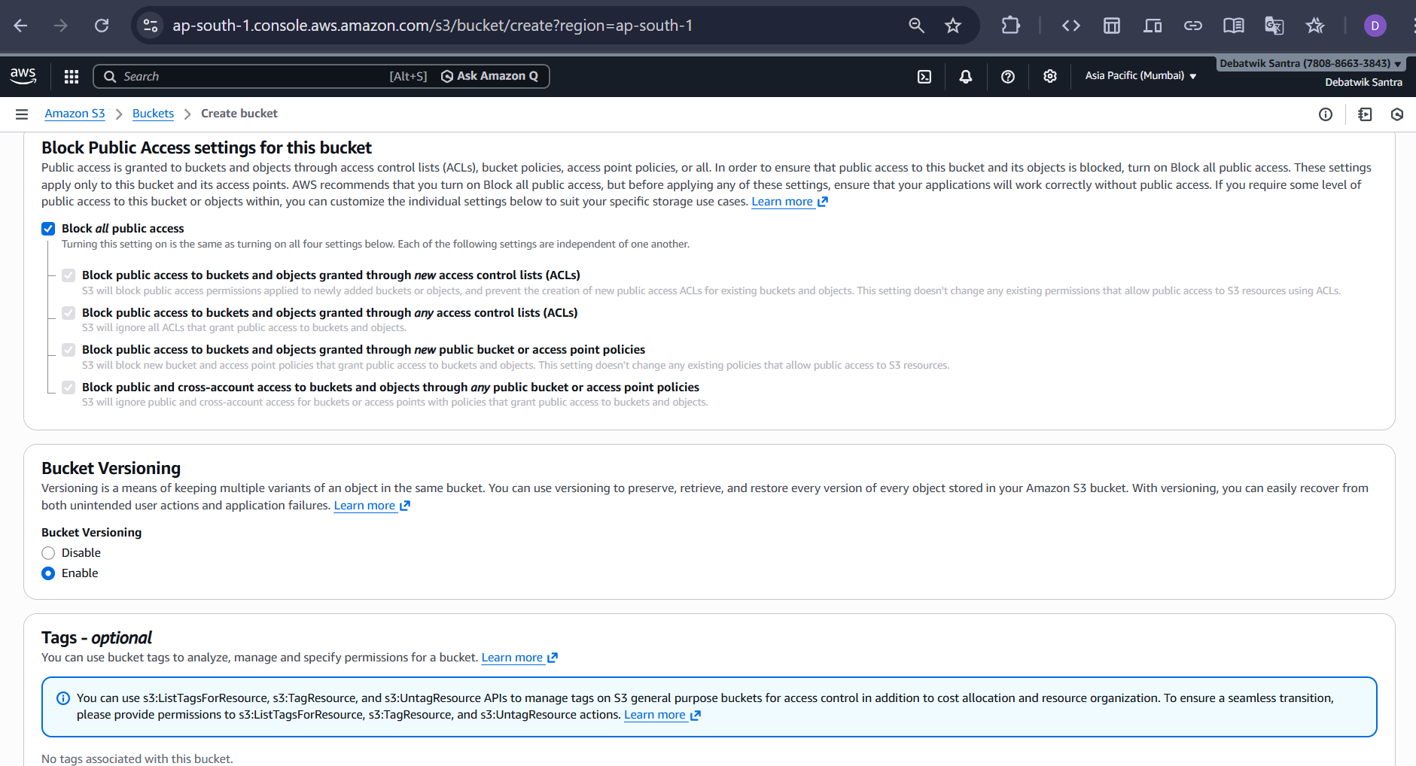

- Under Bucket Versioning: Select Enable and Also Leave the Tags as default(optional). And Click on Create bucket
- PRIVATE bucket is Ready.

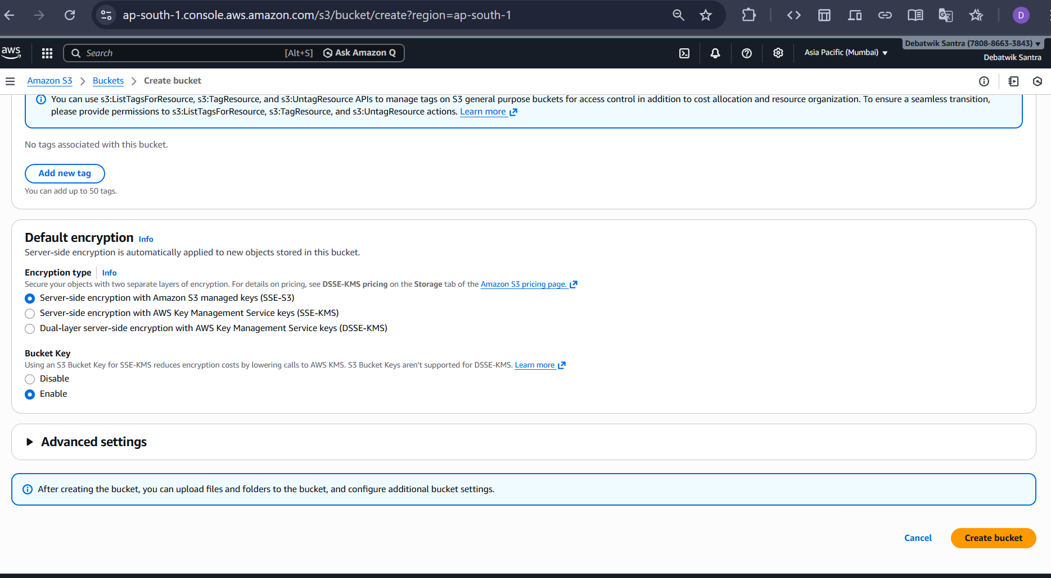

Step 4: Upload File to Bucket
- Open the Recently Created bucket by clicking on it.
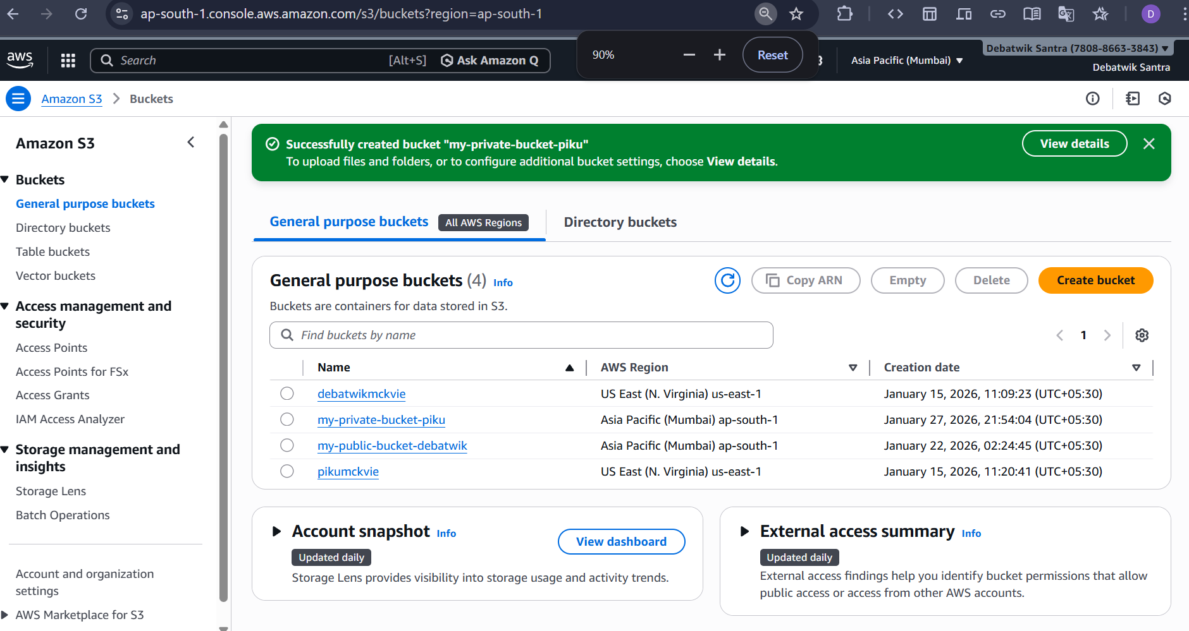
- Click on Upload.
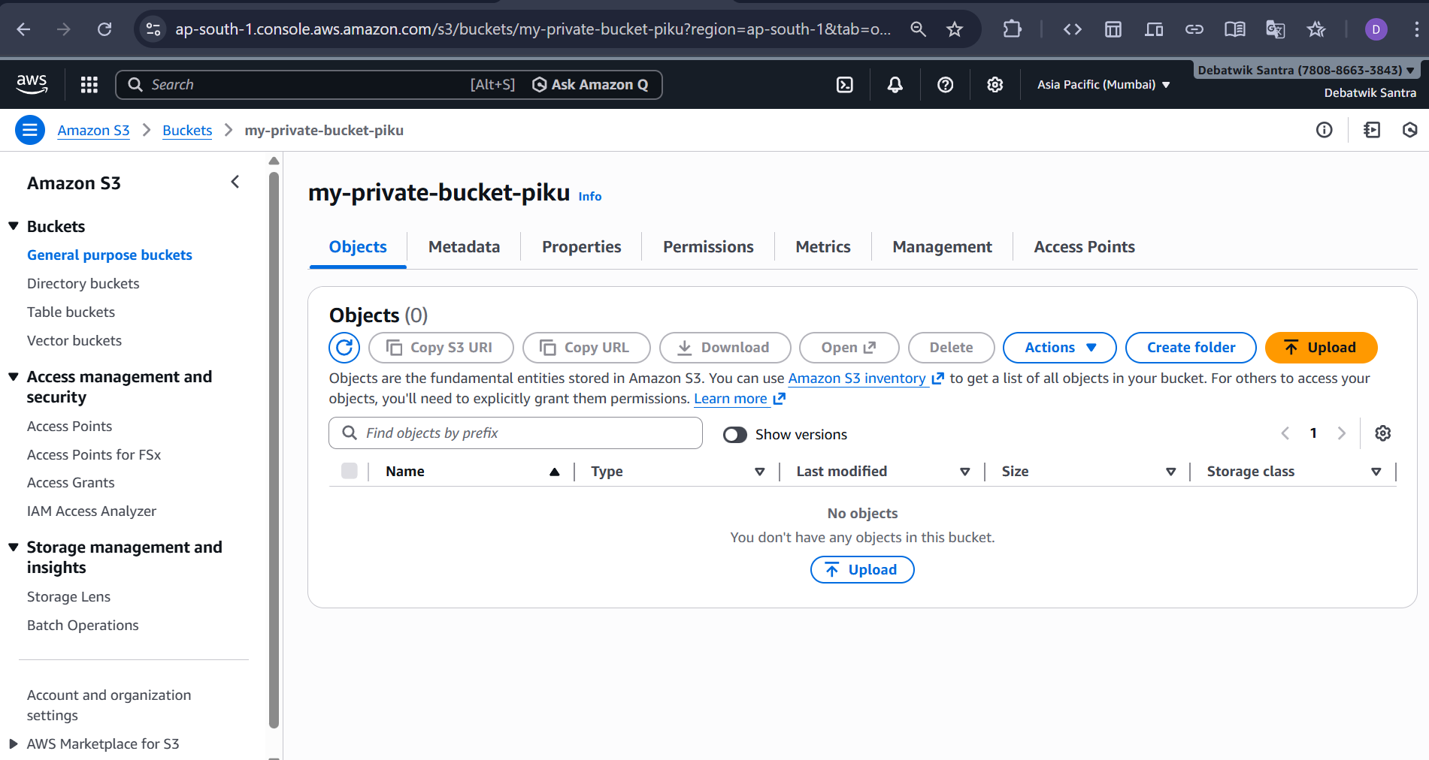
- Click on the Add files and Select any file (any .txt or .jpg file).
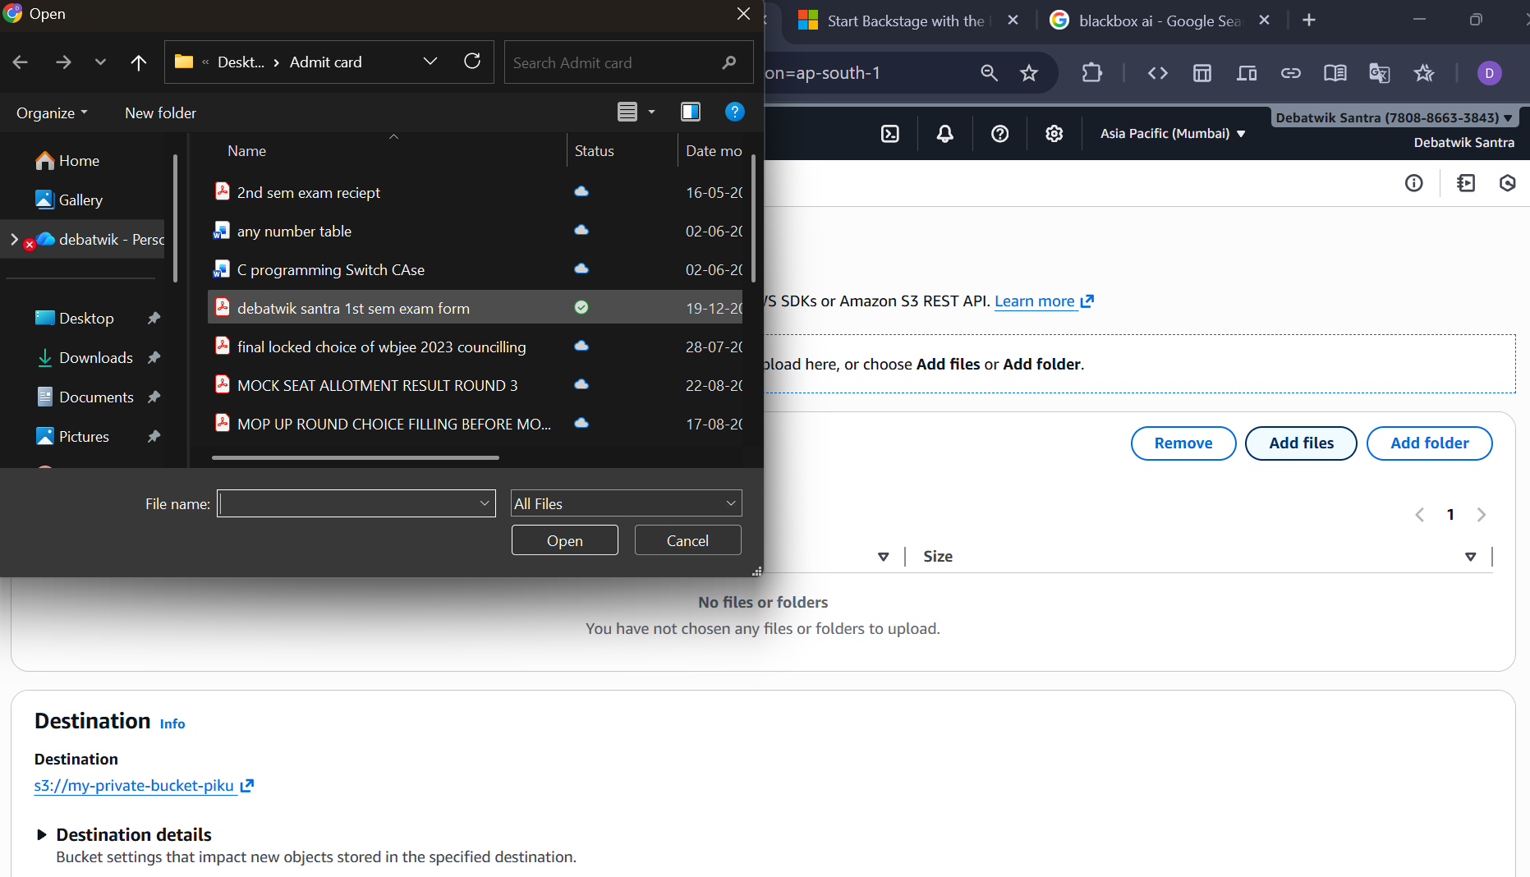

- Click on Upload.
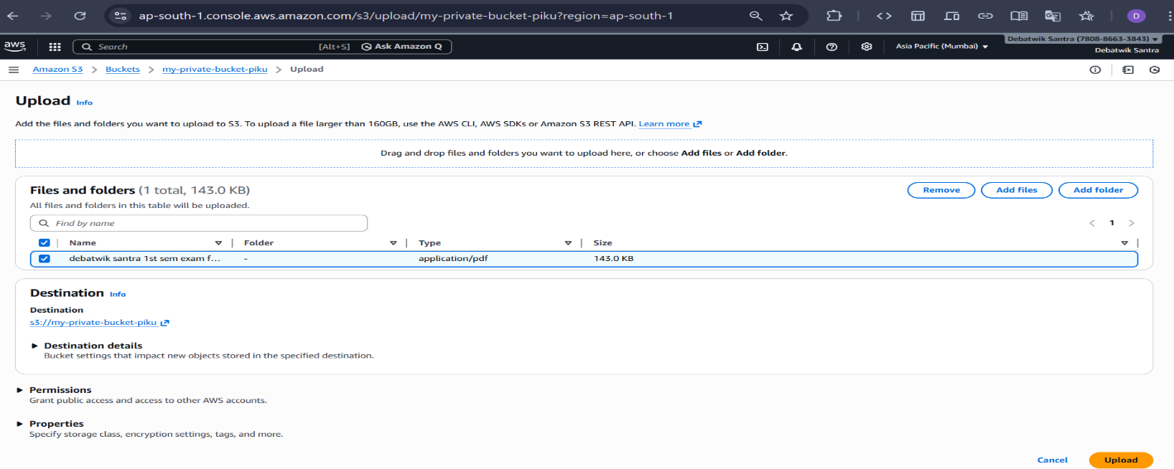
Step 5 : Verify the file is not public
- Now, click on one of the uploaded file, then “Copy URL”.
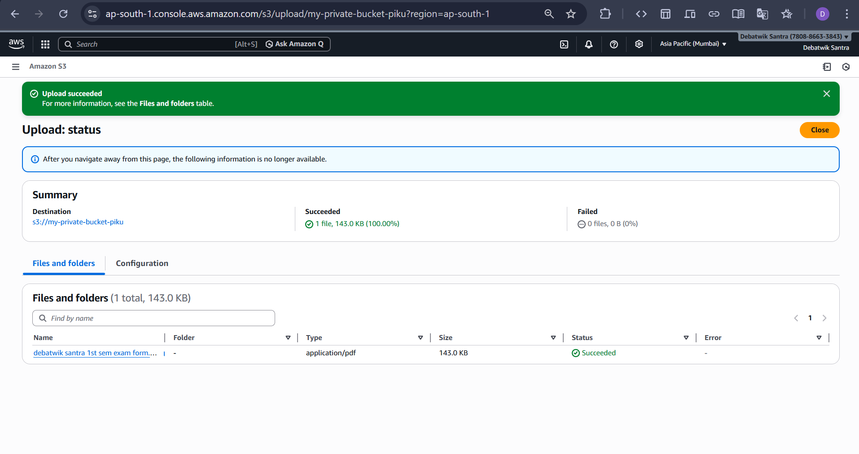
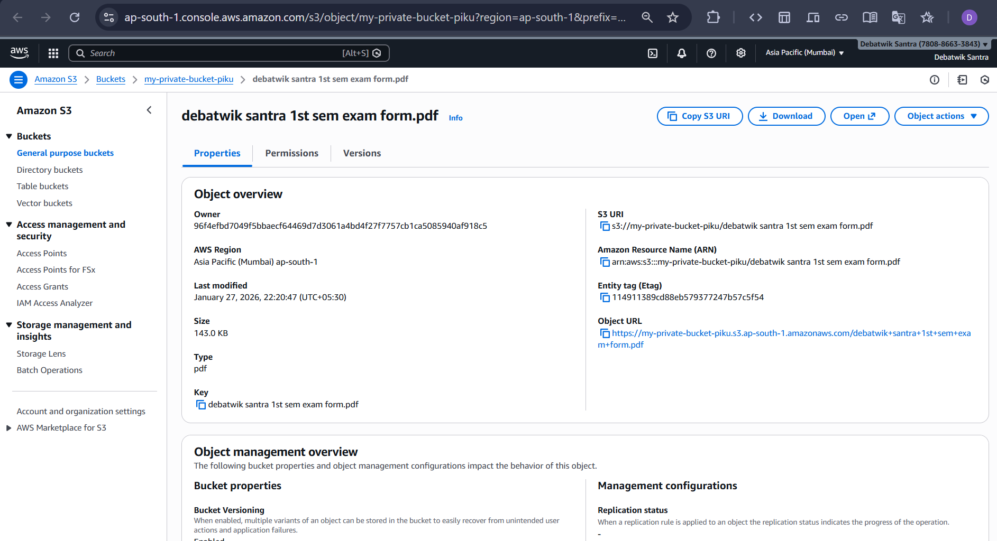
- Navigate on a new window and paste this URL. An error appears indicating that access to the contents is restricted.
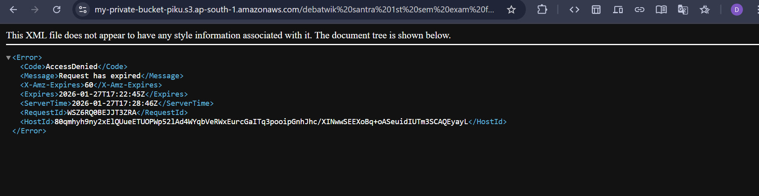
Step 6 : Generate a Pre-Signed URL
- Select the uploaded file
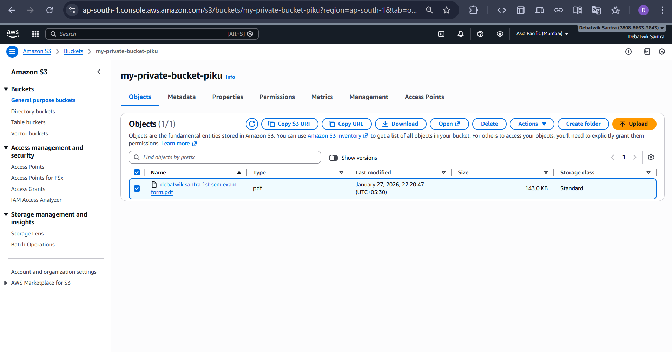
- Click Actions → Share with a presigned URL
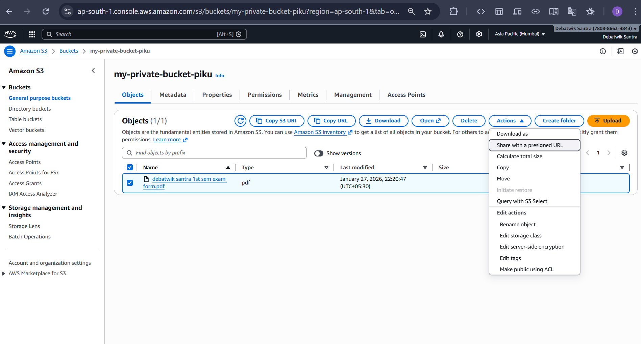
- Set Expiration time (e.g., 1 minutes). Click Create presigned URL.
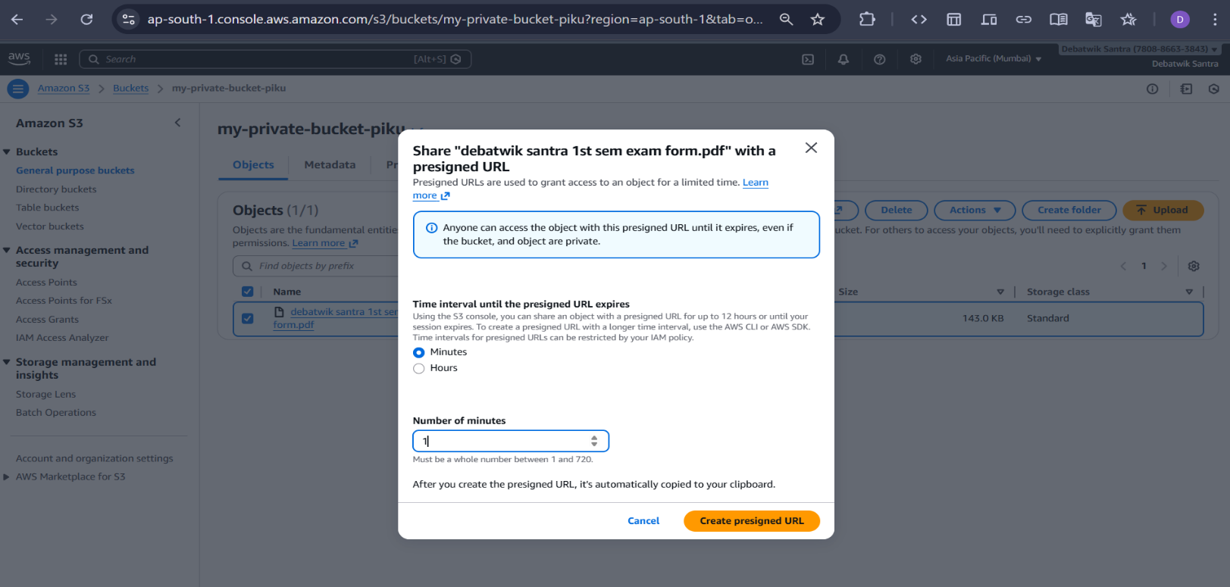
- Copy the generated URL.
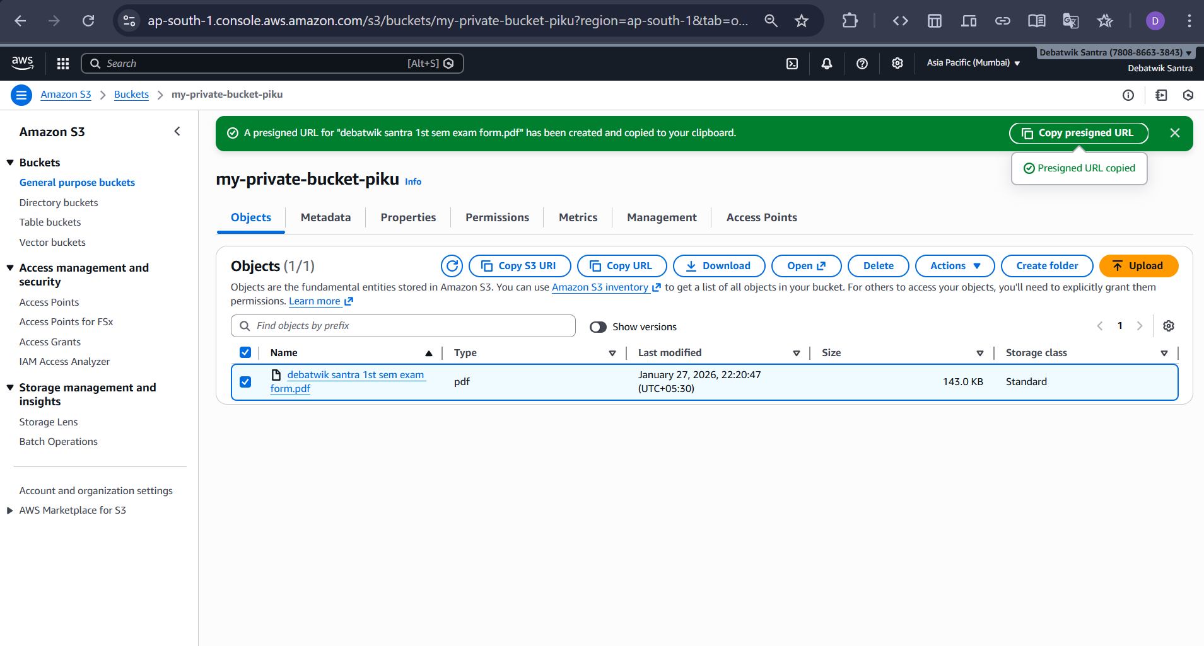

Step 7 : Test the Pre-Signed URL
- Open new browser / incognito mode
- Paste the pre-signed URL
- Press Enter
- File opens / downloads successfully
- Access works ONLY via the pre-signed URL

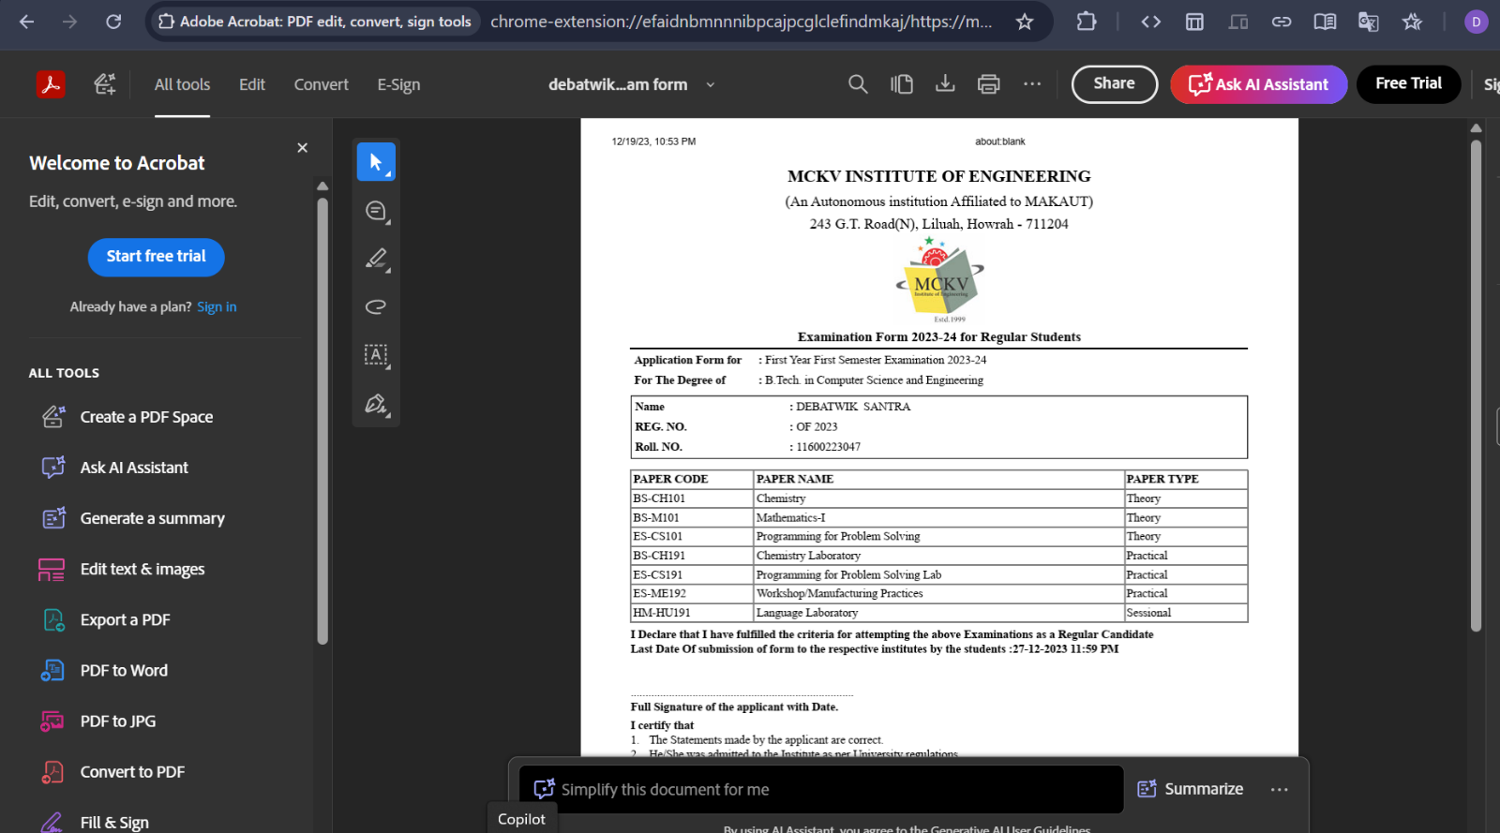
Step 8 : Verify Expiry (Optional but Important)
- Wait until expiration time ends
- Open the same pre-signed URL again
- You’ll see Access Denied / Request Expired

Final Conclusion (Exam-Ready)
- S3 bucket is private
- File cannot be accessed directly
- Pre-signed URL grants temporary access
- After expiry, access is automatically revoked

